STENCIL 5D.
THE FUTURE CONTINUOUS VERSUS THE FUTURE PERFECT

THE FUTURE CONTINUOUS

EXAMPLES
- Tomorrow at this time, I will be taking my English language exam.
- Ben won't be having visitors next week.
- Will you be coming to the party next month?

FORMS
will / won’t | be | present participle
will | be | taking
won’t | be | having
will | be | coming

GRAPH

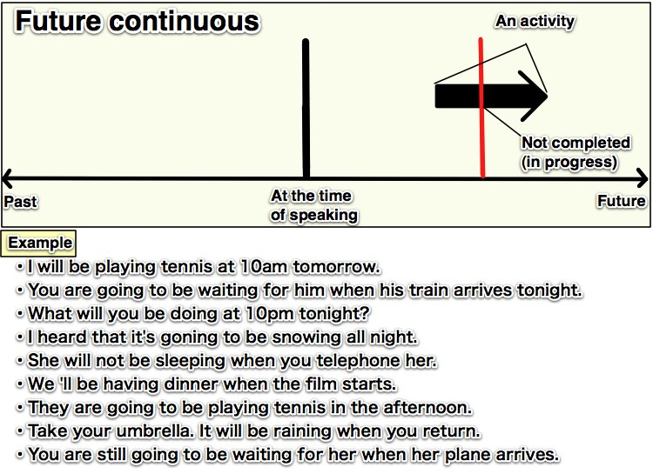
RULE:
We use the future continuous when we want to talk about activities that will be in progress at a certain time in the future.
THE FUTURE PERFECT.
EXAMPLES .
will + have + past participle
- You will have perfected your English by the time you come back from the U.S.
- Will you have perfected your English by the time you come back from the U.S.?
- You will not (won’t) have perfected your English by the time you come back from the U.S

TOEPASSING :

Een handeling/situatie (van kortere of langere duur) die is afgesloten voor een bepaald punt in de toekomst

GRAPH

Examples:

- I will have been in London for six months by the time I leave.
- Doctors will have found a cure for cancer by 2030
- People will have improved the environment by 2025.

